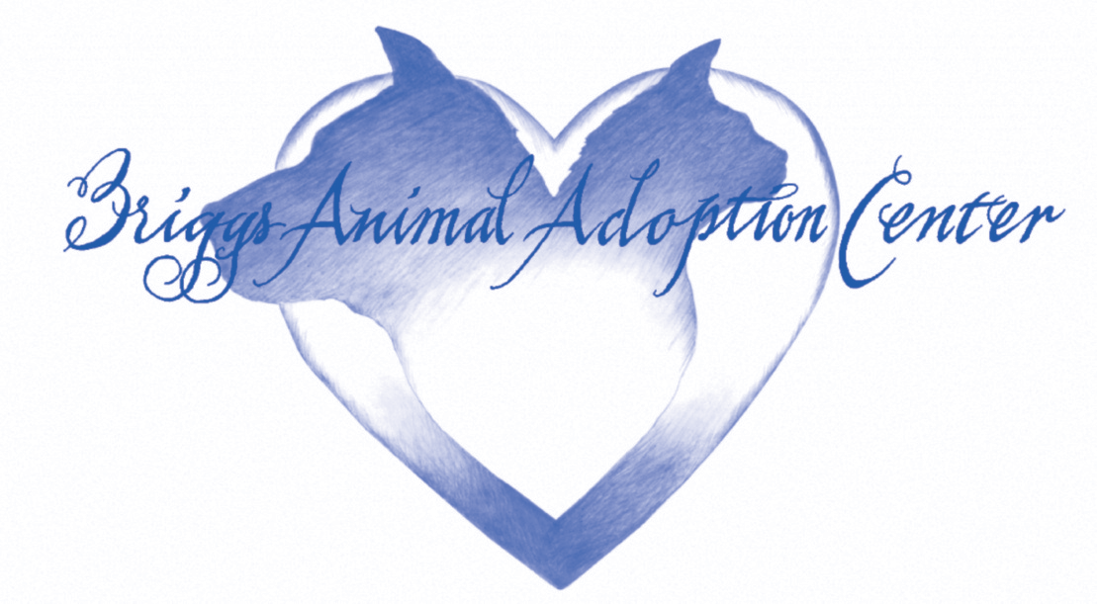

**Veterinary Release Form**

Please fill out this form completely to authorize the release of your pet's medical records or information.

**Owner Information**

**Name: _______________________**

**Address: _______________________**

**Phone number: _______________________**

**Email: _______________________**

**Pet Information**

**Pet's Name: _______________________**

**Species: _______________________**

**Breed: _______________________**

**Age: _______________________**

**Receiving Party Information**

**Name: _______________________**

**Organization: _______________________**

**Address: _______________________**

**Phone number: _______________________**

**Email: _______________________**

**Purpose of Release**

Please specify the reason for this release**: _______________________**

**Authorization and Consent**

I authorize the release of my pet's medical records to the receiving party listed above.

**Name: _______________________**

**Date: _______________________**

P.O. Box 340 Charles Town, WV 25414-1023 304-724-6558 Fax: 304-724-6765

email: [adoptions@nhes.org](mailto:adoptions@nhes.org)

A program of The National Humane Education Society [www.nhes.org](http://www.nhes.org/)